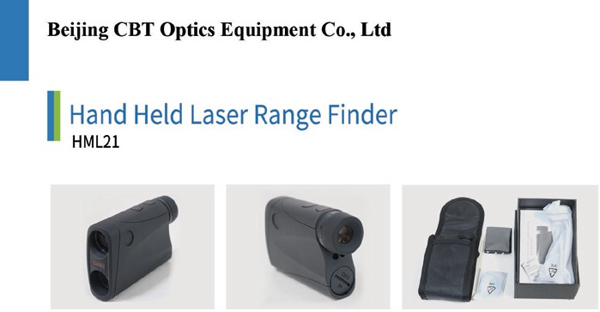

Key Features
It has diopter adjustment function with target priority switch system for measuring overlapping subjects. It Comes with 2 set of rechargeable battery with one charger.

Actual field of view | : 7°
Maximum measurement distance  (Static target) | : 1100m
Minimum measurement distance | : 5m
Maximum measurement distance  (Moving target) | : 650m
Accuracy (Actual distance) | : ±0.5m(5-99m)  ±1m(100m-1100m)
Magnification | : 7x
Power source | : CR2 Lithium battery along with automatic  power shutoff function
Environment condition | : IP x 4
Laser classification | : Class I
Temperature tolerance | : -10oC to +60oC
Standard | : ISO
Accessories | : Lens cleaning kit, Carry bag and operating  manual in English/Chinese

